CS402 Theory of Automata
Final Term Examination – Spring 2006
Time Allowed: 150 Minutes
www.vuzs.net/

 | Question No. 1 |  |  |  | Marks : 1
 | A production of the form non-terminal  non-terminal is called a dead Production.
 | 1. | True
 | 2. | False
 | Question No. 2 |  |  |  | Marks : 3
 | Semi-word is a string having some terminals and one non-terminal at the right of string.
 | 1. | True
 | 2. | False
 | Question No. 3 |  |  |  | Marks : 3
 | Two FAs are equivalent if they have same no. of states.
 | 1. | True
 | 2. | False
 | Question No. 4 |  |  |  | Marks : 1
 | There exist exactly two different derivations in an ambiguous CFG for a word.
 |  | 1. | True
 |  | 2. | False
 | Question No. 5 |  |  |  | Marks : 1
 | Construct RE’s for following languages over Σ= {a, b}
 | i. | All words which contain substring “baba”. |  |  | [5]

 | ii. All words which never end in substrings “aa” and “ab” |  | [5]
 | Question No. 6 |  | Marks : 1
 | Regular languages are closed under Union, Concatenation and Kleene star.
1. |  | True
2. |  | False
 | Question No. 7 |  | Marks : 1
 | CFG may also represent a regular language.
1. |  | True
2. |  | False
 | Question No. 8 |  | Marks : 1
 | Find the complement of the FA below,
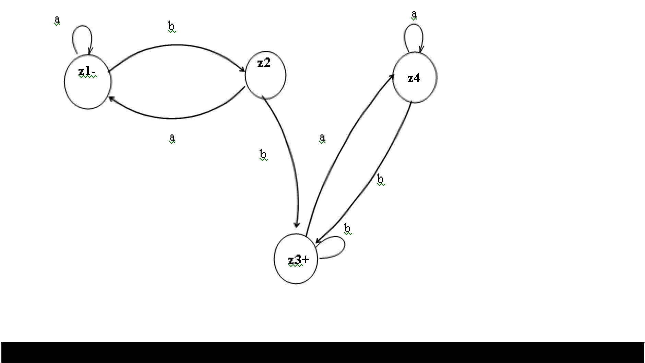

Question No. 9 Marks : 1

PDA is stronger than FA. 3. True

4. False

Question No. 10 Marks : 3

Union of two FAs is an FA that accepts all the string of FA1 and FA2.

True

False

 | Question No. 11 | Marks : 3
 | Given a CFG below,
 | a) Remove Unit productions from the CFG. | [5]

S → S + T | T

T → T * F | F
F → ( S ) | a

 | b) | Derive CNF corresponding to the CFG given below. [10]
 |  | S → ABa
 |  | A → aab
 |  | B → Ac
 | Question No. 12 |  | Marks : 10
 | In non-deterministic PDA a string may be traced by more than one paths.
1. |  | True
2. |  | False
 | Question No. 13 |  | Marks : 1
 | There always exist an FA for each PDA.
 | True
 | False
 | Question No. 14 |  | Marks : 1
 | a) Given an FA below, |  | [5]
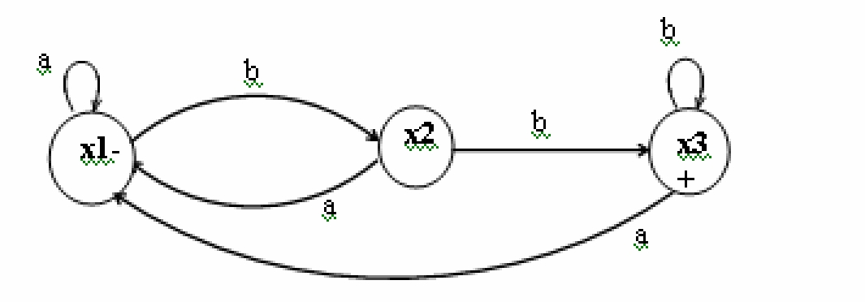

What is language accepted by above FA?

b) Draw a non-deterministic PDA for the above FA. [10]

